Managing Resources and Notifications in UnDesked
This document provides detailed instructions on how to manage resources and notifications within the UnDesked platform. Users can learn how to add, configure, and utilize various tools like uploads, media, forms, tests, acknowledgements, agreements, external links, badges, and notifications.

Step 1
To access your resources, click on either "Visitors" or "Users," then select "Resources." This will display all the different resource types available in UnDesked. Uploads are documents you may need from users, such as an I-9 form, passport, or driver's license.
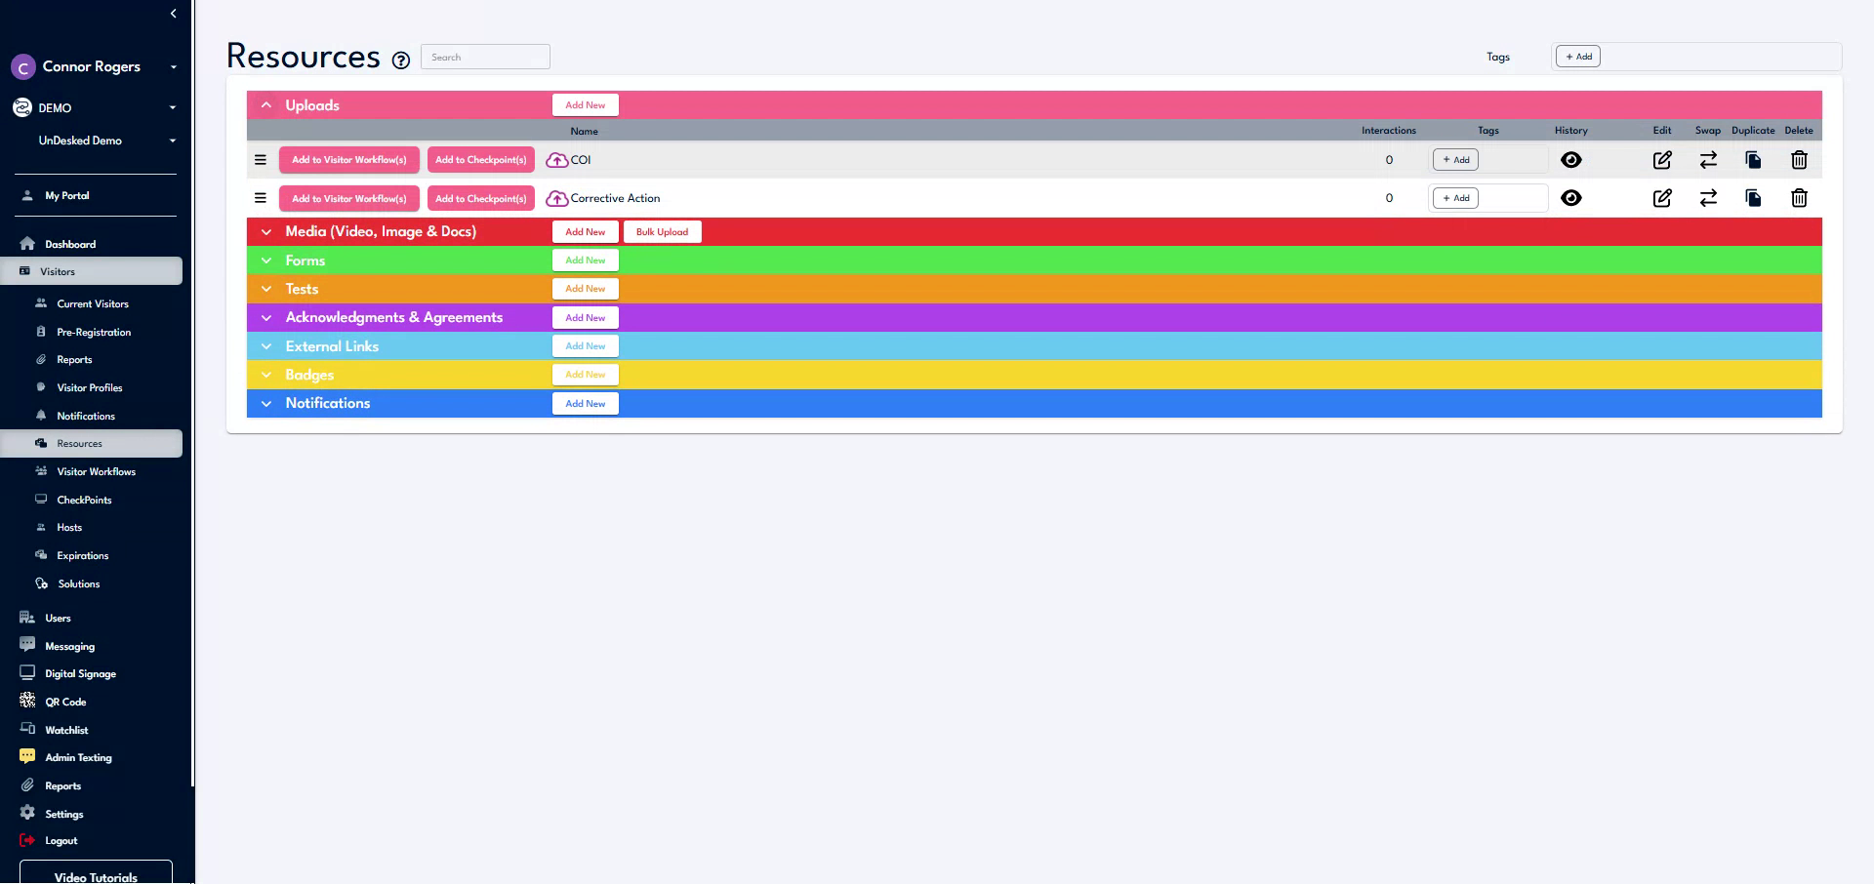

Step 2
To add a new upload, click "Add New," enter a name, set a reserve period, and enable an expiration date if desired. Media consists of all videos, images, and documents. To add new media, click "Add New," upload the media file, and provide a name along with setting a reserve period if needed.
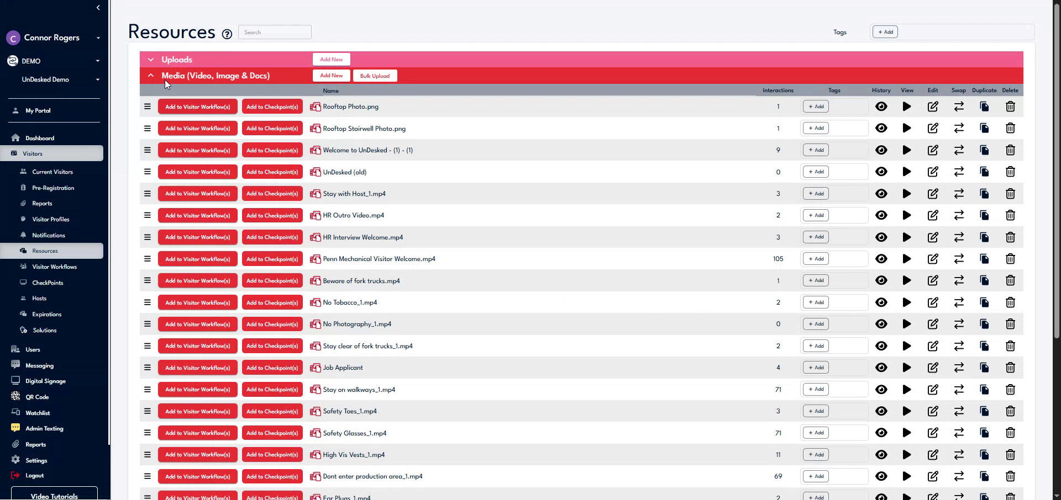

Step 3
Forms are documents used to collect or deliver information to users. To add a form, click "Add New," name the form, set a reserve period if desired, and add items such as multiple-choice questions, checklists, dropdowns, required signatures, or attachments.
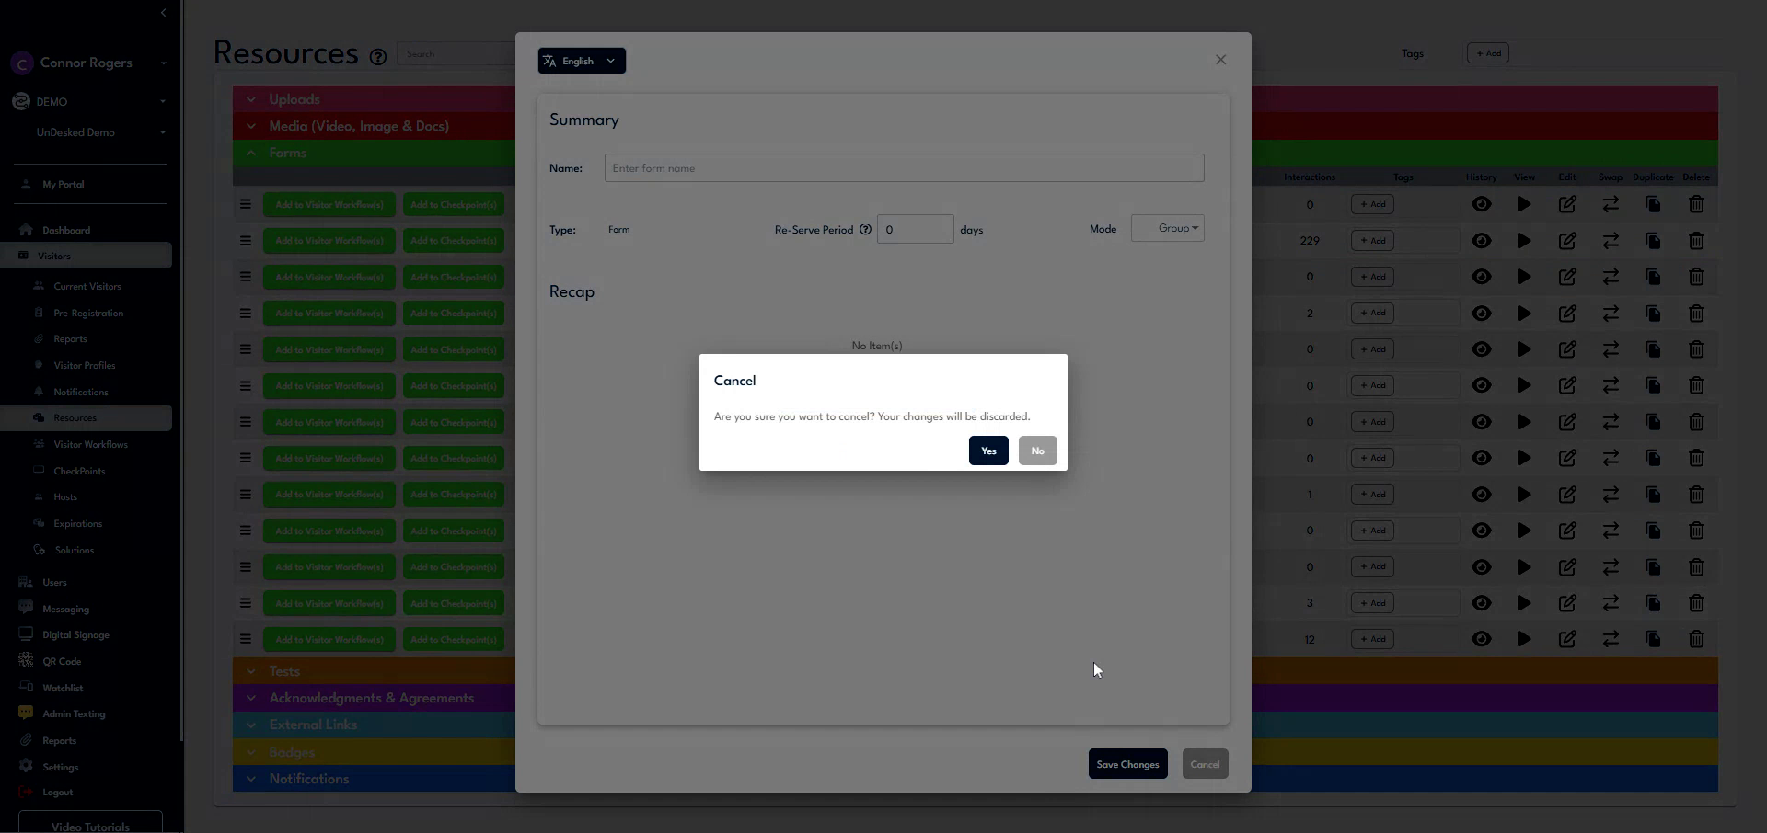

Step 4
Tests can be scored and may trigger workflows or other resources based on pass or fail outcomes. To add a new test, click "Add New," name the test, set a reserve period and retry period if desired, then define the pass-fail parameters.
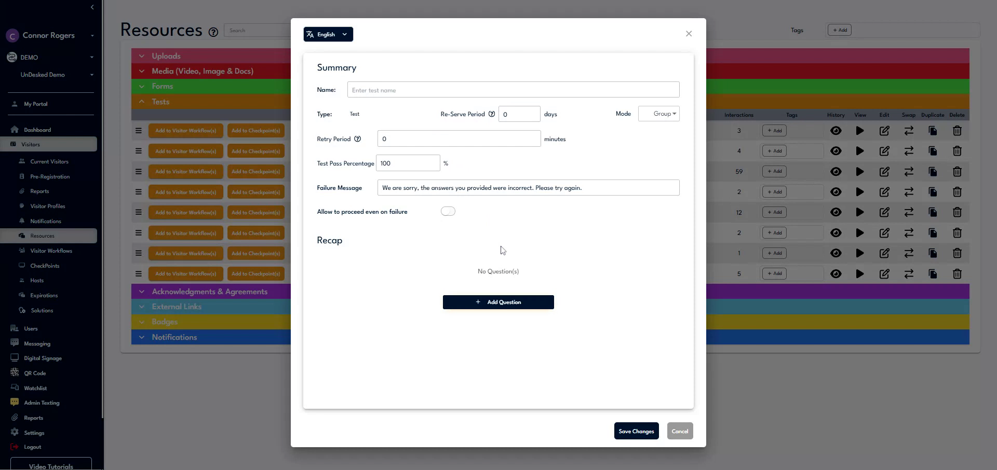

Step 5
Add questions to the test by using the "Add Questions" button.
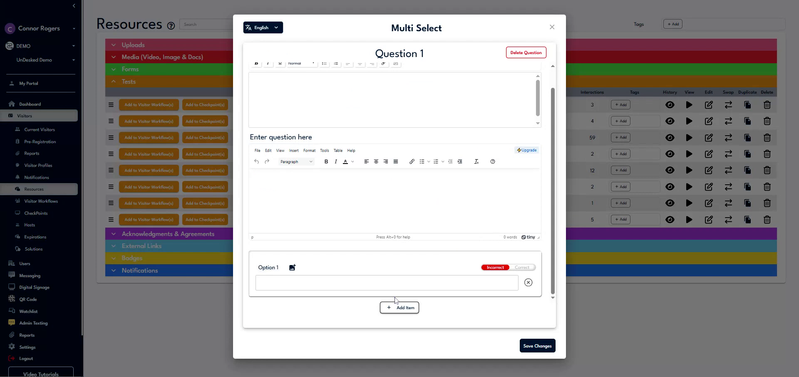

Step 6
Acknowledgements and agreements require user consent via a click or signature. To create a new acknowledgement or agreement, click "Add New," name it, set the reserve period, and enter the agreement text. You can also upload existing documents such as text documents or PDFs by clicking "Select Content."
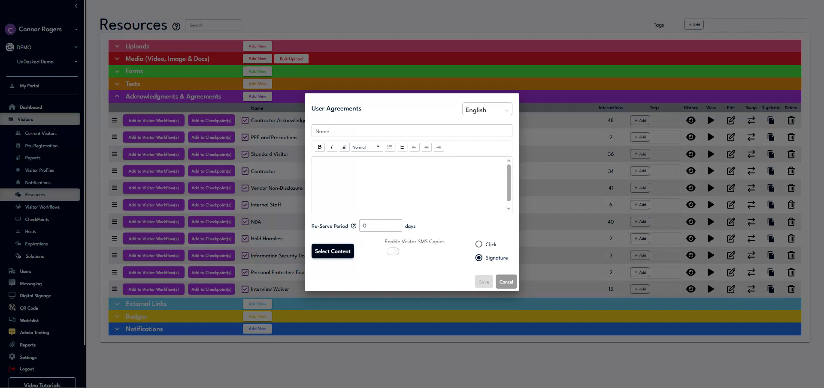

Step 7
Decide whether you want the acknowledgement to be in the form of a click or a signature.
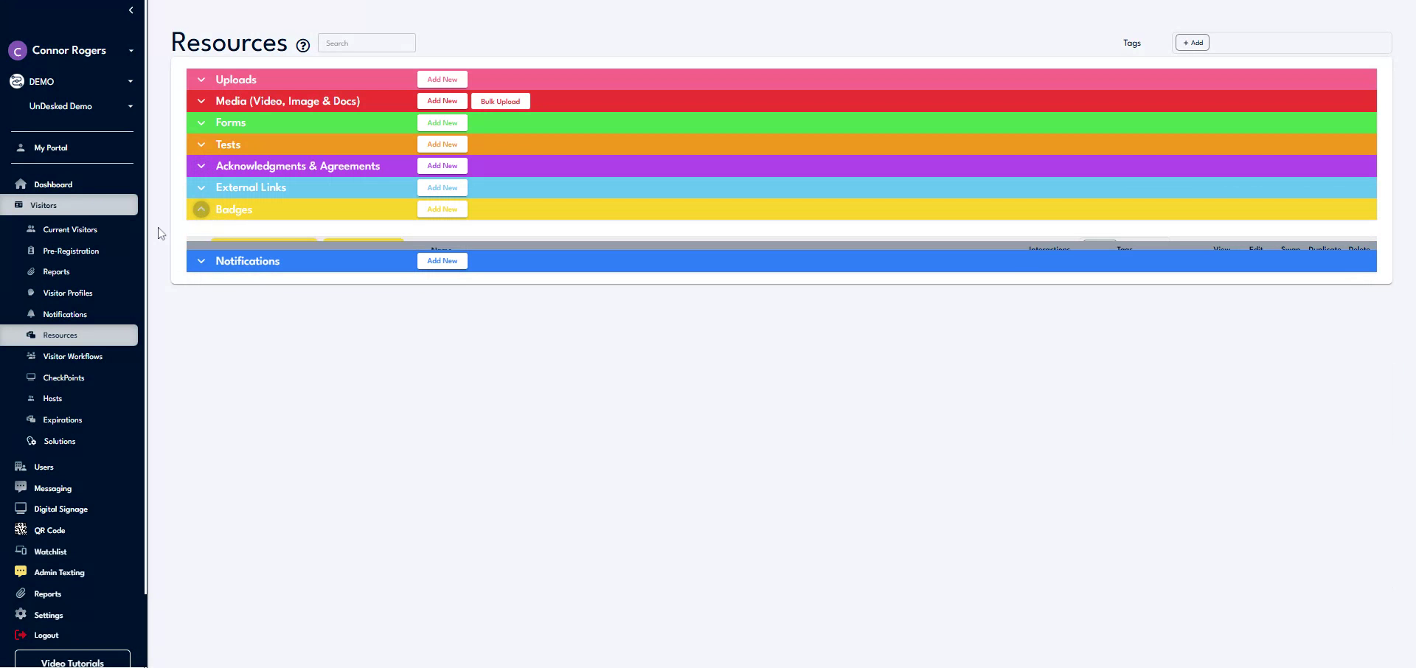

Step 8
External links allow you to use URLs from outside the platform within UnDesked. To add a new external link, click "Add New," assign a name, and enter the direct URL. Badges are physical items that can be printed during a check-in or workflow.
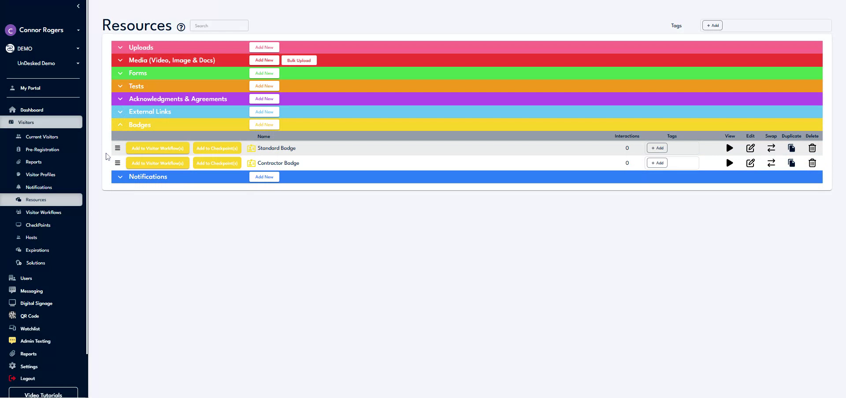

Step 9
To add a new badge, click "Add New," name the badge, and adjust the parameters to modify the information displayed on the badge.
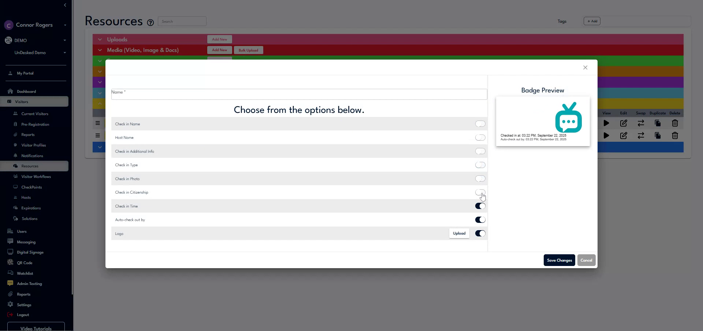

Step 10
Notifications can be triggered during check-ins, workflows, or other platform actions, and can be delivered via text message, digital signage, email, or Teams integrations. To create a new notification, click "Add New," name it, assign the workflow and trigger, and select the notification recipients.
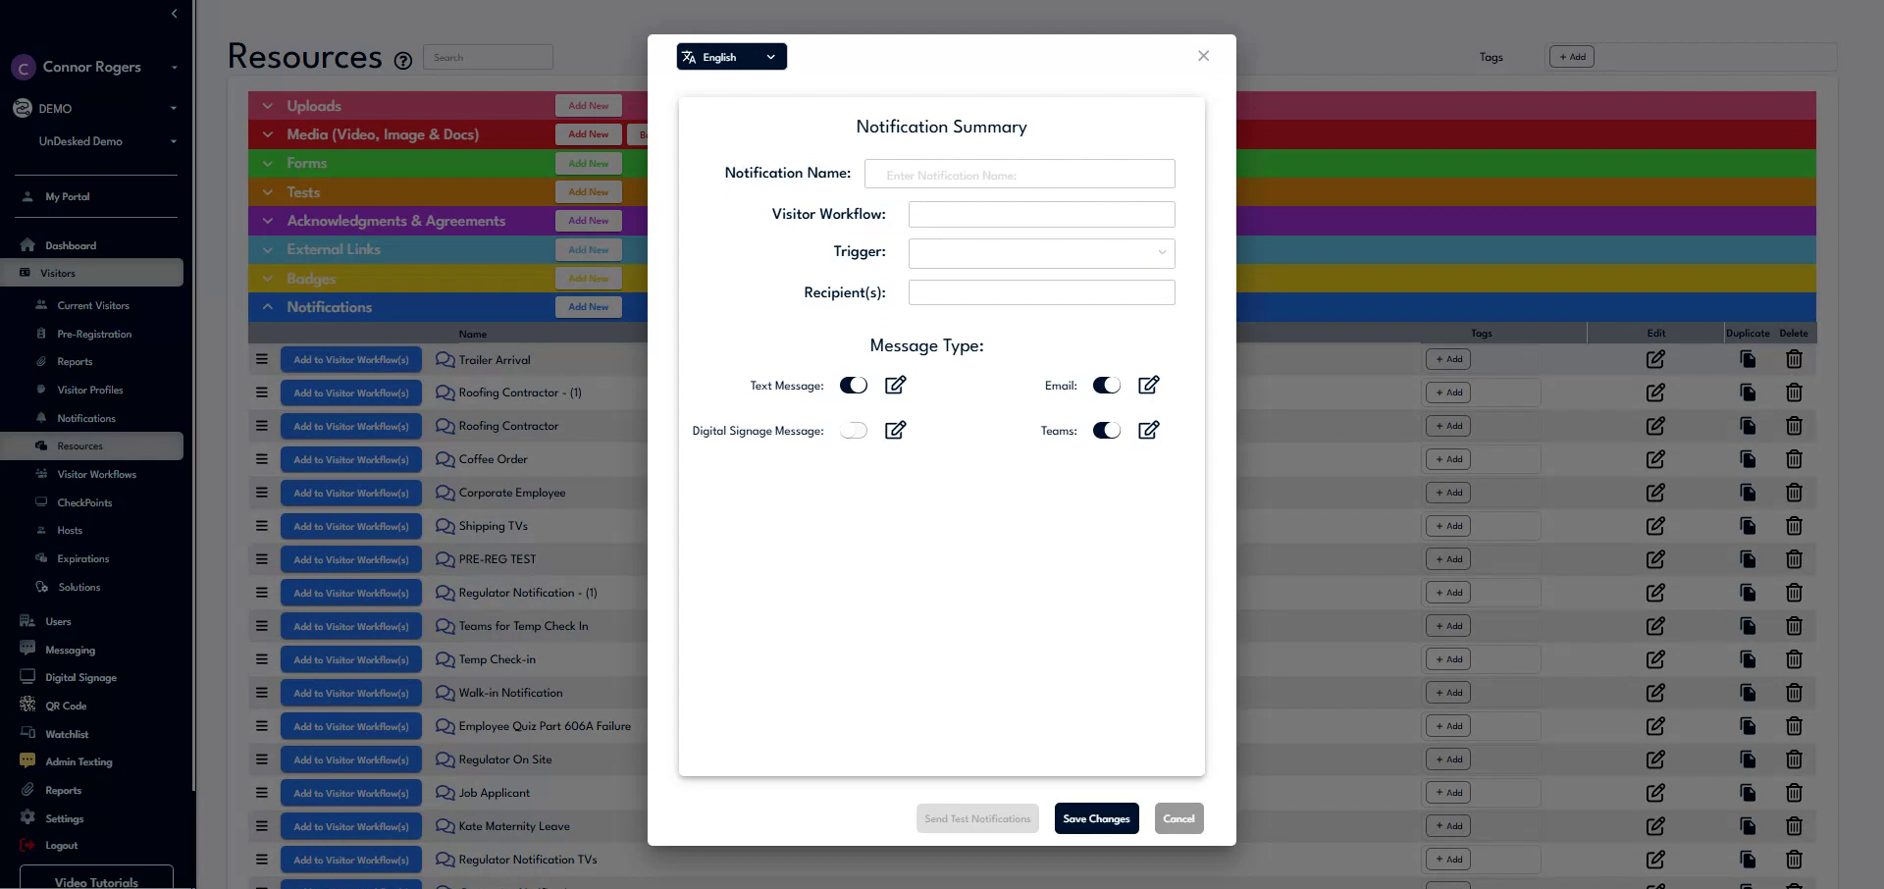

Step 11
You can add multiple recipients as needed. Toggle the message types for the notifications, and click the pencil icon next to the toggle to edit the notification text. Use the dropdown at the top right to add conditional variables provided by the UnDesked system if necessary.
